**Requirements**

**Introduction**

Purpose: To provide a platform and network where those who are passionate about cooking can meet and share recipes with one another.

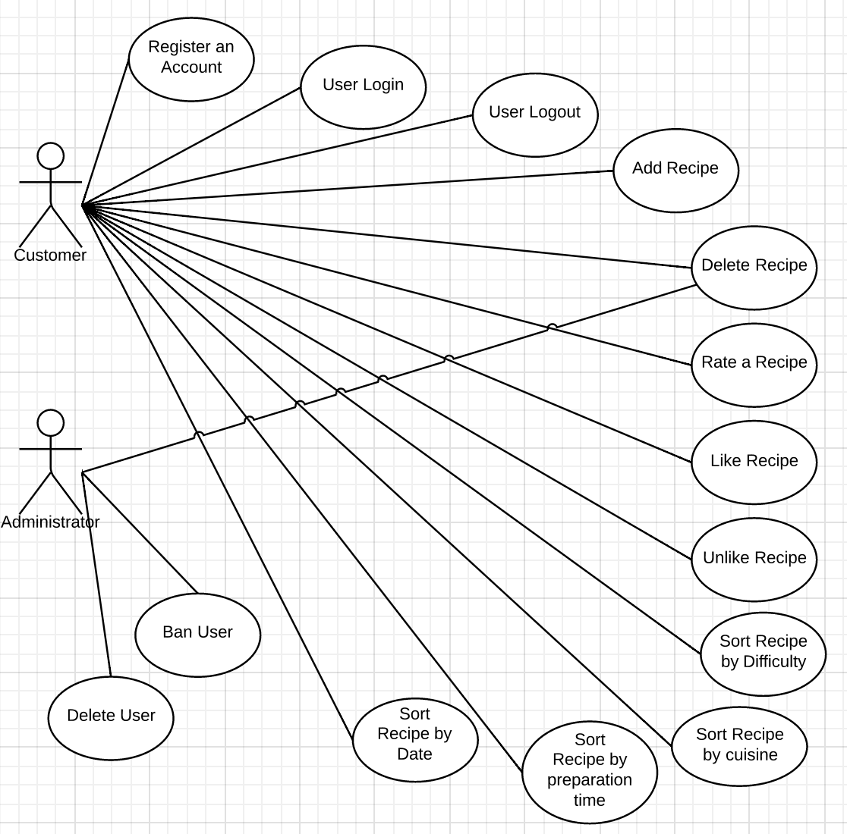**Use Case Diagram**

**Identify Actors**

The actors will be customers (app users) and company management/staff (labelled as Administrators). The app users are labelled as customers because in the entire purpose of this app is to monetize it in a real world scenario and thus any user when monitized will become a customer.

**Identify Scenarios**

|  |  |
| --- | --- |
| *Scenario name* | sort RecipeByCuisine |
| *Participating actor instances* | Bob, User |
| *Flow of events* | 1. Bob, is wondering what he will eat for dinner. He comes to conclusion he wants mediterranean. He opens the cooking application. 2. the cooking application displays dropdown menus . And clicks on mediterranean as a option under the dropdown menu cuisine. 3. All mediterranean cuisine is displayed 4. Bob decides and the information is displayed once Bob picks and option. |

*Scenario name:* deleteBowlOfCerealRecipe

*Participating actor instance: Lee*

*Flow of events:*

1. Lee opens the application on his mobile device.

2. Lee clicks the Sign In button and enters his username and password followed by clicking the login button.

4. His login information is verified as correct and he is logged in.

5. Lee clicks the My Profile button and is brought to his profile page.

6. Lee clicks the Delete button beside his Bowl of Cereal recipe.

7. Lee clicks the Yes button when given the confirmation popup.

8. The recipe is removed from both Lee's profile and the database.

*Scenario name:* addBowlOfCornFlakesRecipe

*Participating actor instance: Lee*

*Flow of events:*

1. Lee opens the application on his mobile device.

2. Lee clicks the Sign In button and enters his username and password followed by clicking the login button.

3. His login information is verified as correct and he is logged in.

4. Lee clicks the Add Recipe button.

5. Lee enters the Recipe Name: Bowl of Corn Flakes, the Prep and Cook Time: 2 and 0 mins, the Ingredients List: cereal and milk, the Category: Lazy, the Step by Step Directions: pour corn flakes in bowl, pour milk on cereal, enjoy, the Difficulty Rating (out of 5): 1, adds fancy a photo of the bowl of corn flakes, and adds the Number of Servings: 1, Lee does not add any extra notes about the recipe.

6. Lee clicks submit and recipe is added to database along with Lee's username, and the Current Date: October, 30, 2014.

*Scenario name* rateCereal

*Participating actor instances* Ryan: User

*Flow of events* 1. Ryan is hungry and wants to find an easy recipe to make, so he opens up the application.

2. Ryan enters his username and password and is logged in to the application.

3. Ryan browses a list of recipes and finds one for a bowl of corn flakes.

4. Ryan clicks on the recipe and is brought to the recipe page. He follows the instructions and makes himself a bowl of cereal.

5. After enjoying his cereal, he looks back at the recipe page and rates the recipe 4 stars.

6. He then closes the application.

**Use cases**

|  |  |
| --- | --- |
| *Use case name* | sortByCuisine |
| *Participating actor* | Invoked by User |
| *Entry condition* | 1.The User opens cooking application |
| *Flow of events* | 2. User clicks Sign in button and precedes to enter their username and password in the corresponding fields.  3.user submits login information by clicking the Login button.  4.If login information is verified as correct, user is logged in.  5. User opens dropdown menu under heading cuisine.  6. User clicks on mediterranean which is dislayed as one of the numerous options displayed under cuisine.  7. all cuisine uploaded by users that were identified as mediterranean are displayed in most recently added order.  8. user clicks on Red-Wine Risotto  9. ingredients ,cooking time , prep time, step by step directions and etc are all displayed under the Red-Wine Risotto |
| *Exit condition* | 10. user finishes cooking and closes app |

*Use case name:* addRecipe

*Participating actor instance: User*

Entry Condition: 1. User opens application.

*Flow of events:* 2. User clicks Sign In button and precedes to enter their username and password in the corresponding fields.

3. User submits login information by clicking the Login button.

4. If login information is verified as correct, user is logged in.

5. User clicks Add Recipe button.

6. User enters Recipe Name, Prep and Cook Time, Ingredients List, Category, Step by Step Directions, Difficulty Rating (out of 5), adds a photo, Number of Servings, Extra Notes (optional).

Exit Condition: 7. User clicks submit and recipe is added to database along with Username of user, Current Date.

*Use case name:* deleteRecipe

*Participating actor instance: User*

Entry condition: 1. User opens application.

*Flow of events:* 2. User clicks Sign In button and precedes to enter their username and password in the corresponding fields.

3. User submits login information by clicking the Login button.

4. If login information is verified as correct, user is logged in.

5. User clicks the My Profile button and is taken to their profile page.

6. User scrolls through their list of recipes and beside the desired recipe, clicks the Delete Recipe button.

7. A confirmation popup is displayed with text "Are you sure you would like to delete this recipe?" along with a Yes button and a No button.

Exit Condition: 8. If user clicks yes, the recipe is removed from both their profile and the database.

*Use case name*  The RateRecipe

*Participating actor* Invoked by User

*Entry condition* 1. User opens application

*Flow of events* 2. User clicks Sign In button and proceeds to enter their username and password in the corresponding fields.  
3. User submits login information by clicking the Login button.  
4. If login information is verified as correct, User is logged in.

5. User browses the database of recipes and selects one.

6. The application brings up the recipe page including all details about the recipe and a five star rating system where a sequence of five star images is shown.

7. User clicks on the number of stars they wish to rate the recipe as (out of 5).

8. The database is updated by setting the recipe’s rating to the average number of stars it received from all of its ratings.

*Exit condition* 9. User closes the application.